Queries Output according to new Database Design.

Query 1.1

O/P -> 110574 Tweets_in_total are present

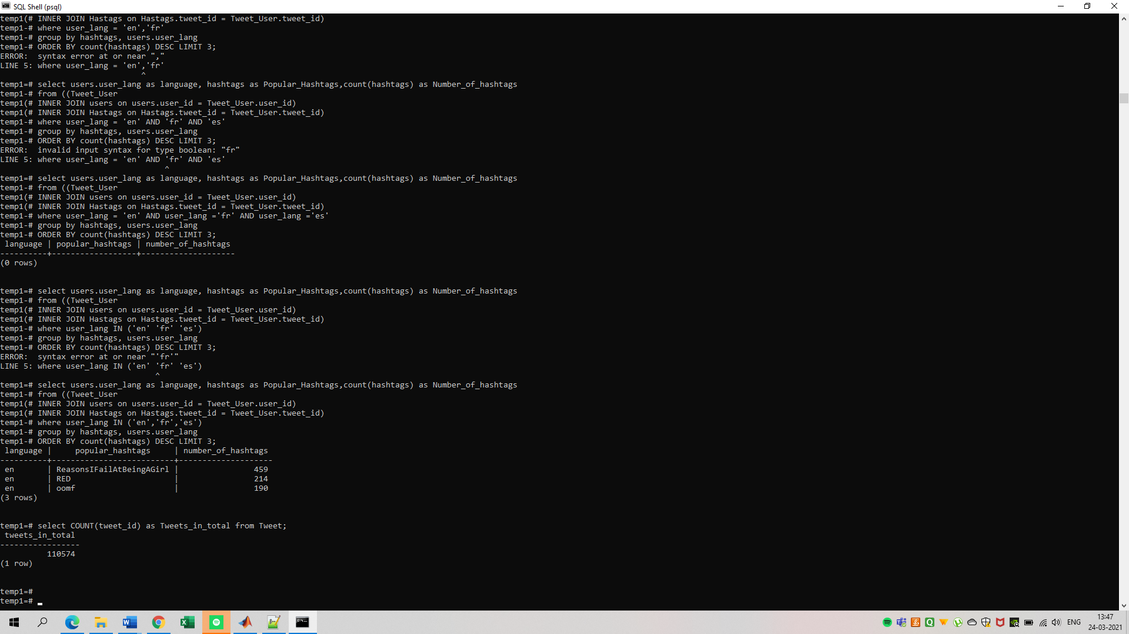

Query 1.2

O/P -> It shows how many tweets were made for that language in database.

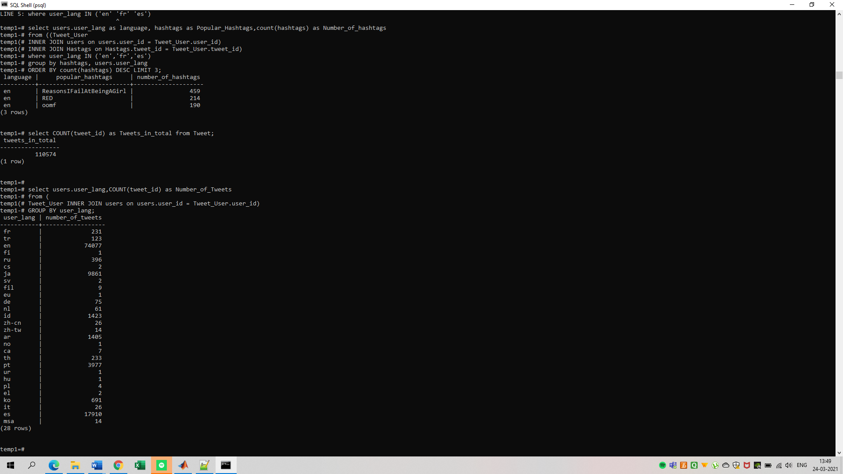

Query 1.3

O/P -> It shows Fraction of Tweets and Fraction of Users per language

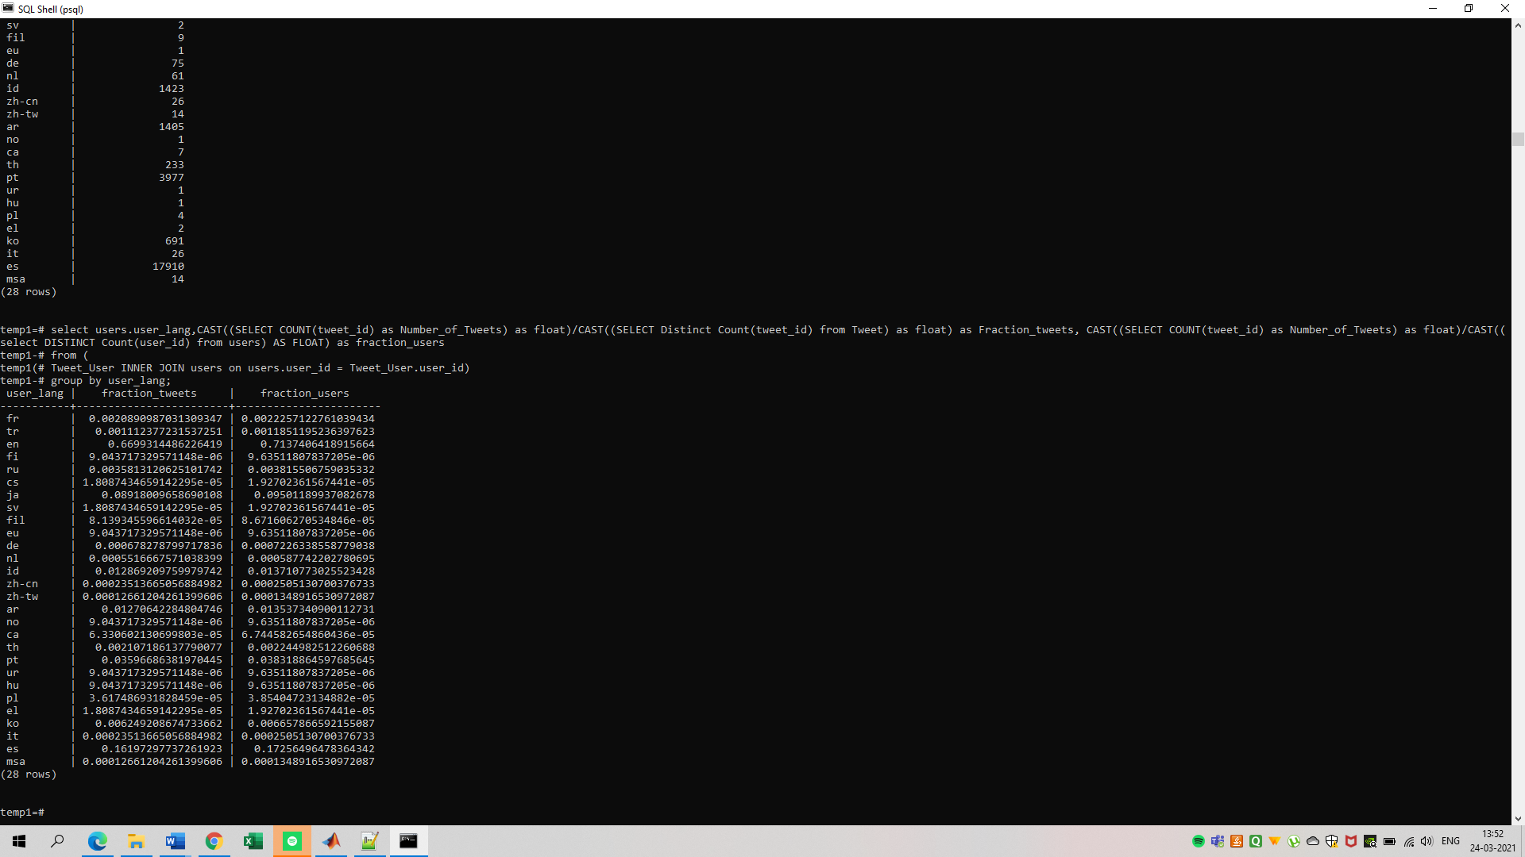

Query 2.1

O/P -> Fraction of tweets which are Retweets.

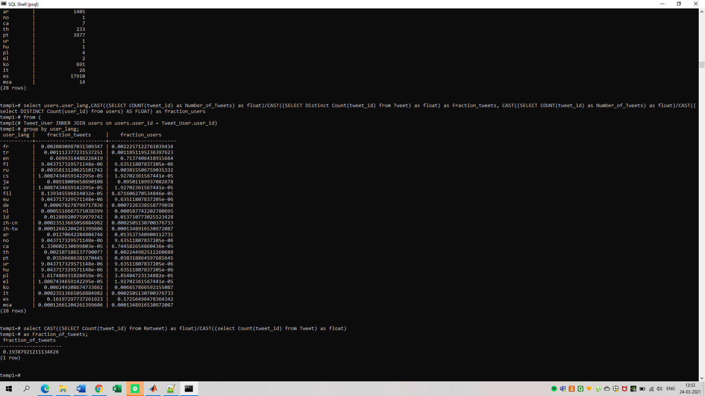

Query2.2

o/p-> Avg of tweet Retweeted

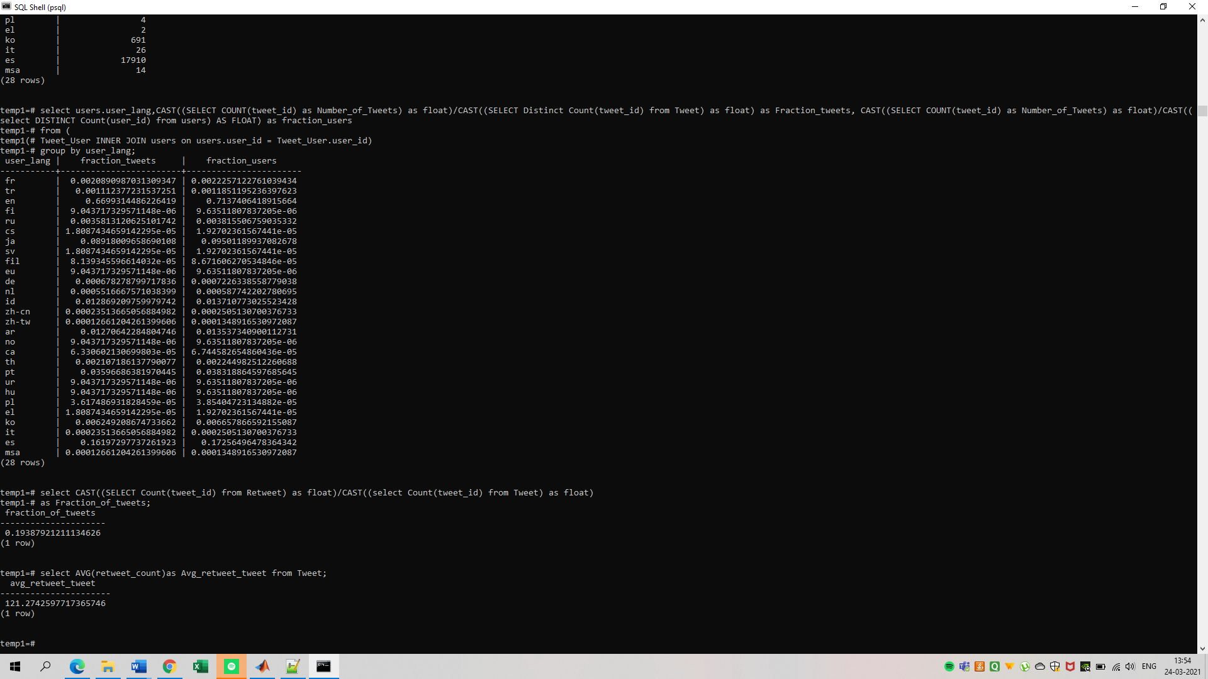

Query 2.3

o/p - > Fraction of tweets never retweeted

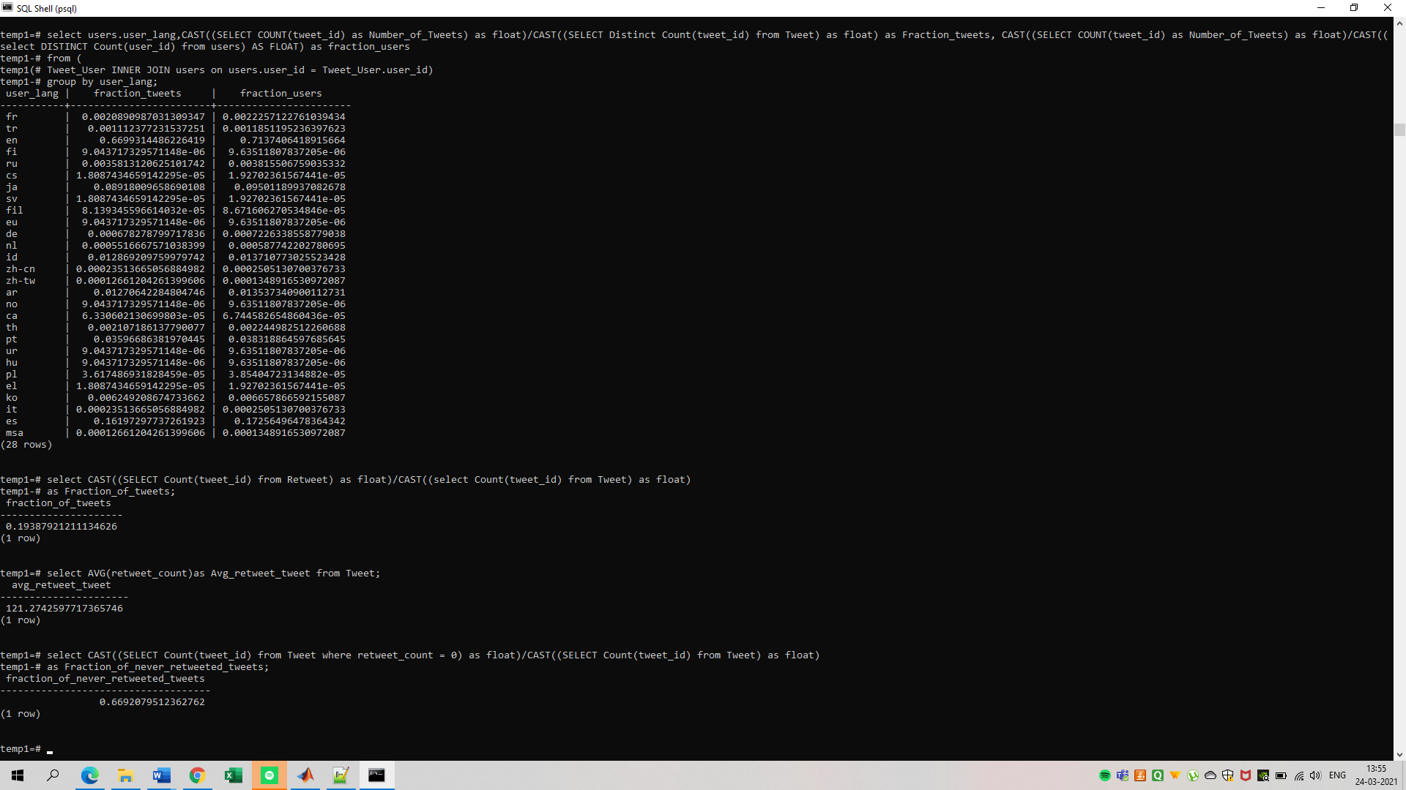

Query 2.4

o/p -> Tweets which were retweeted fewer times

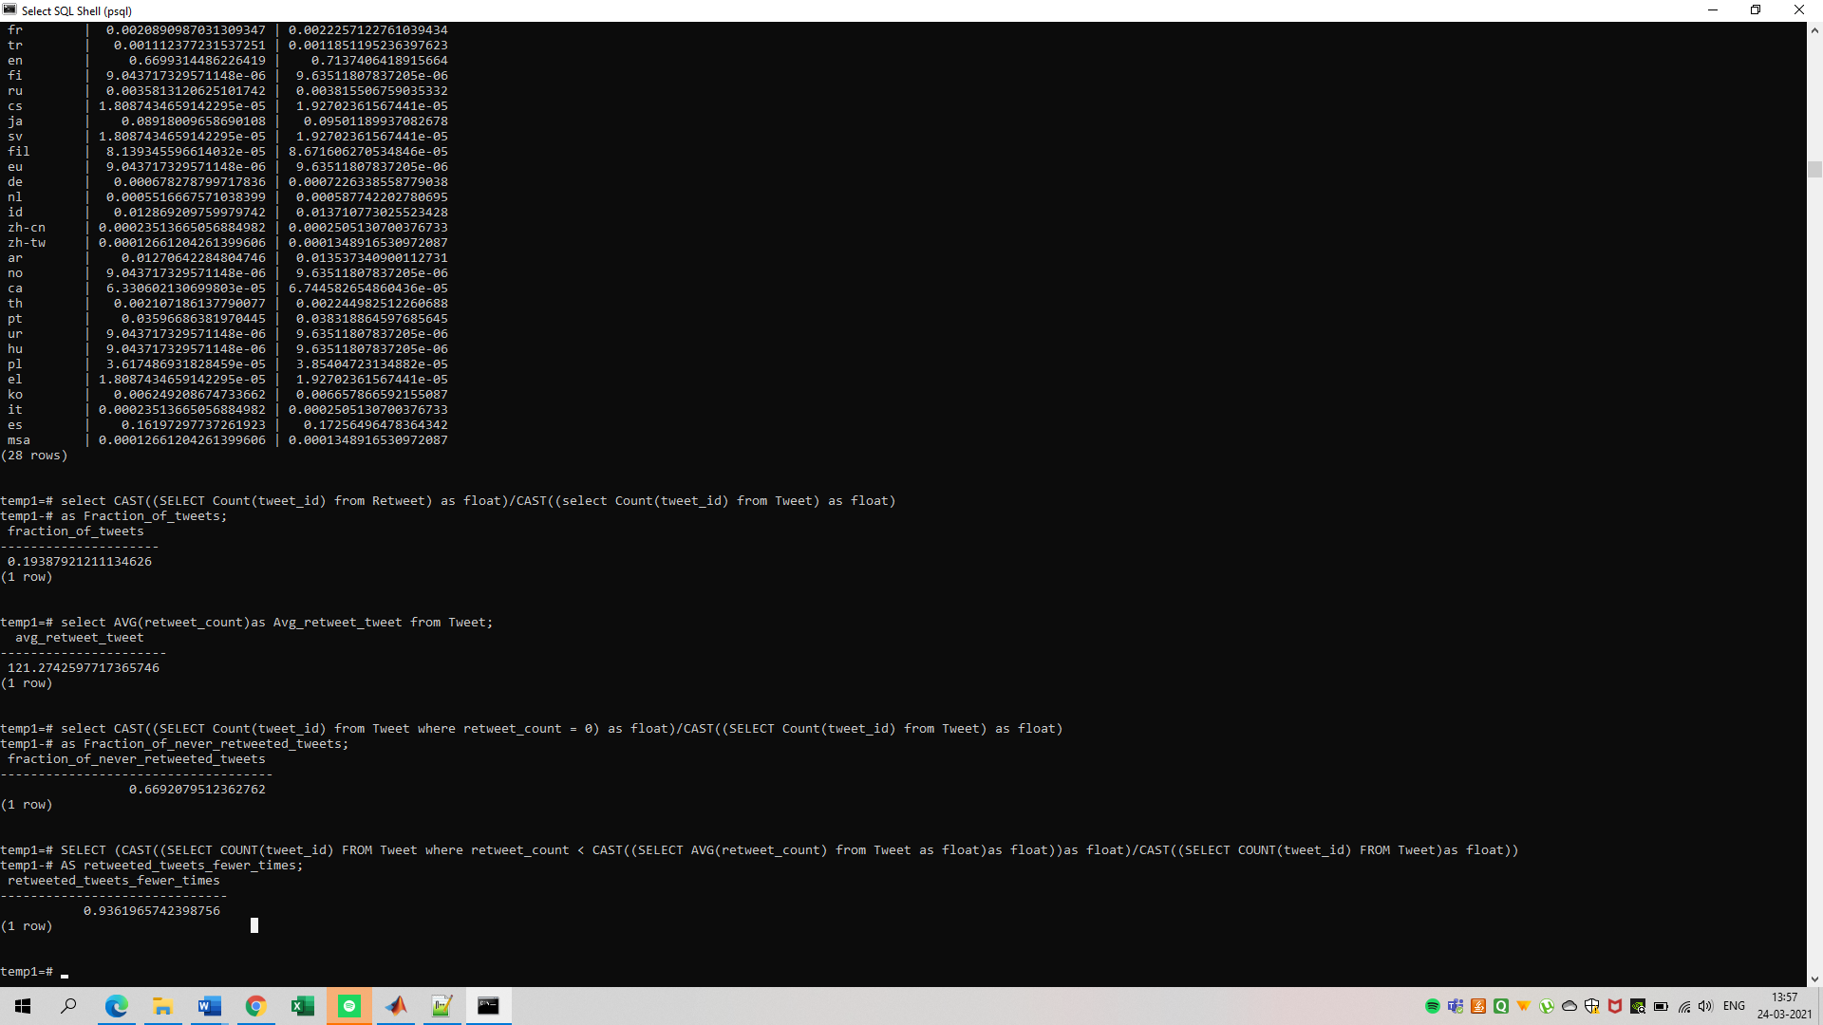

Query3.1

o/p -> Distinct hashtags in table

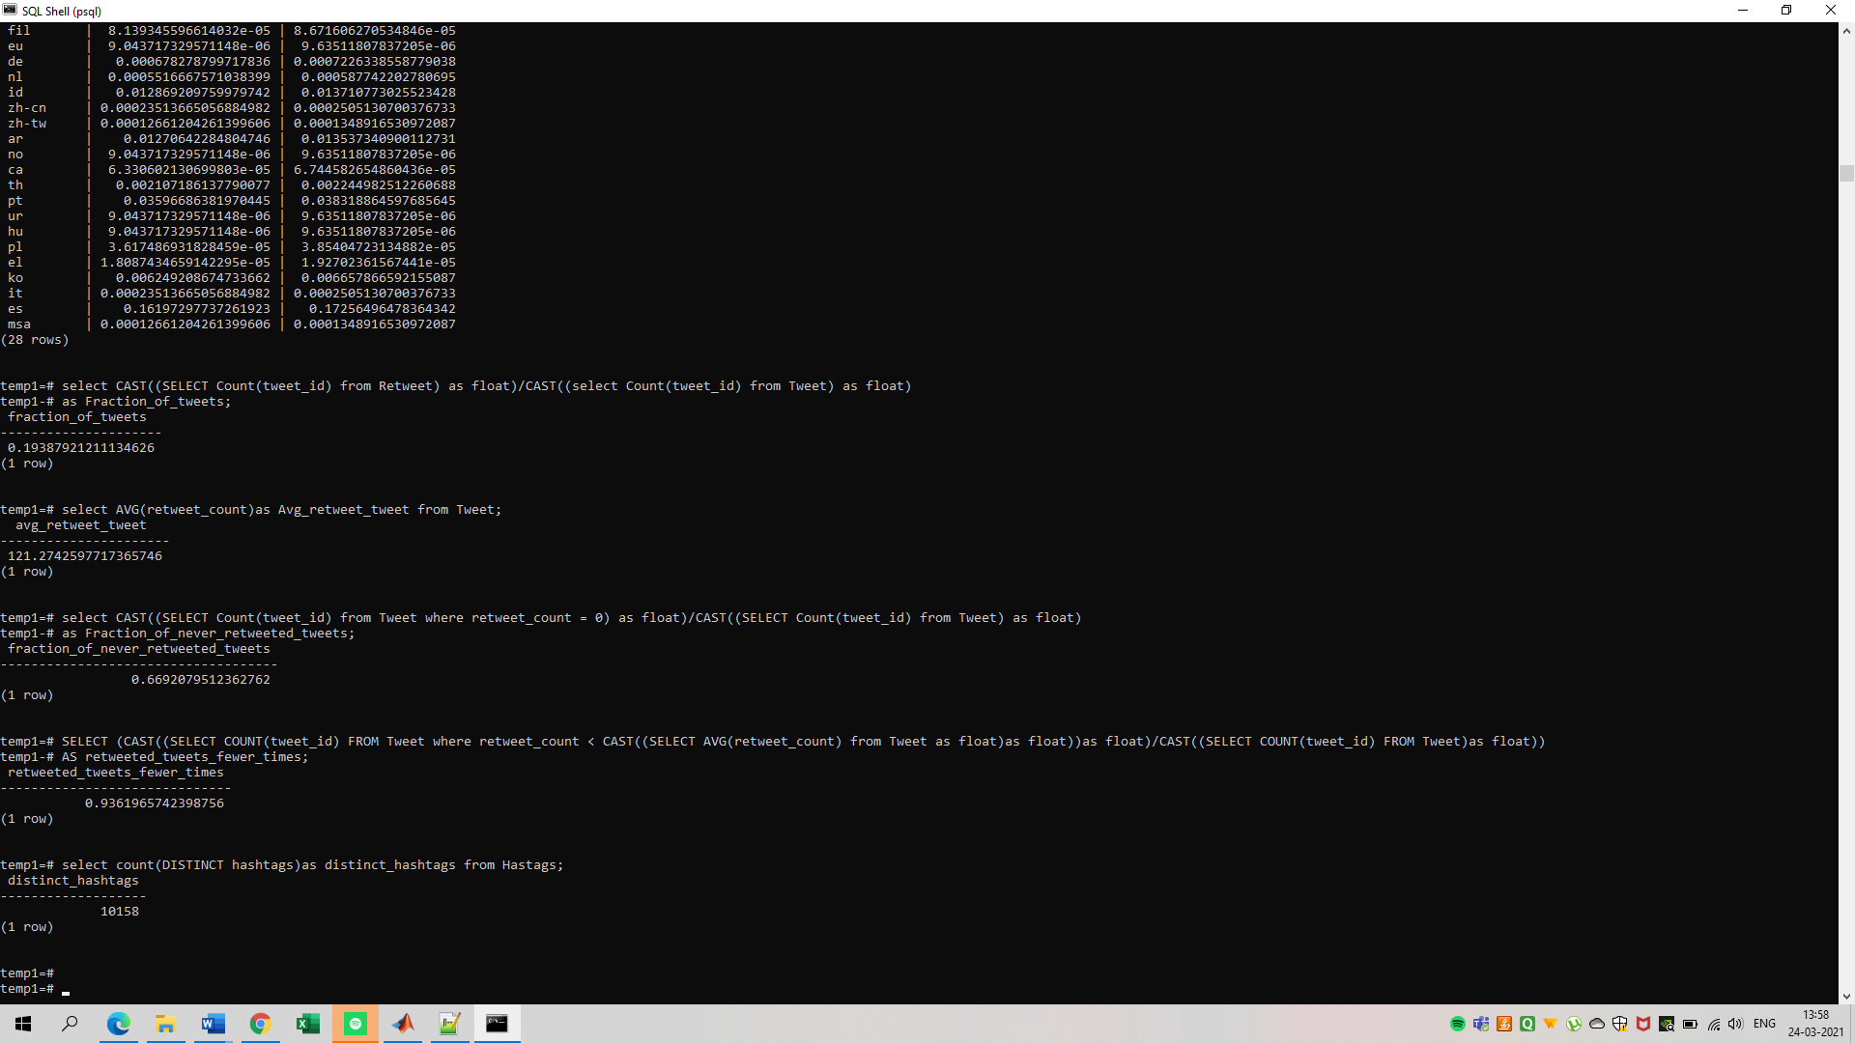

Query3.2

o/p -> Top 10 hashtags used according to language

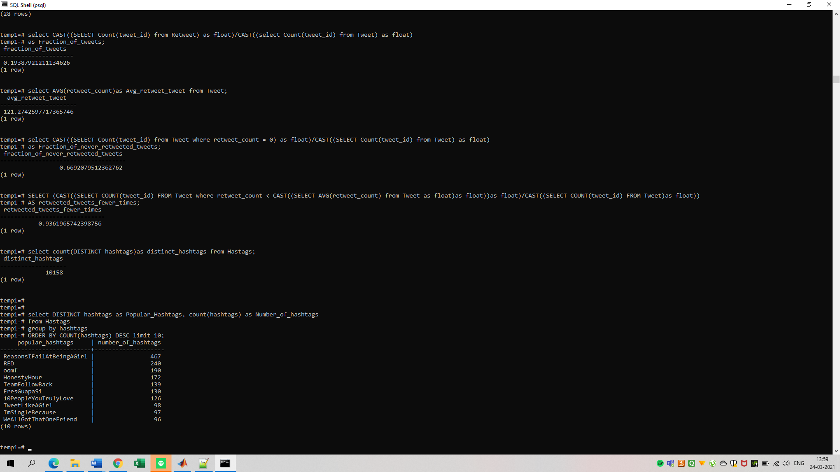

Query 3.3

o/p - > This query gives output only for one language

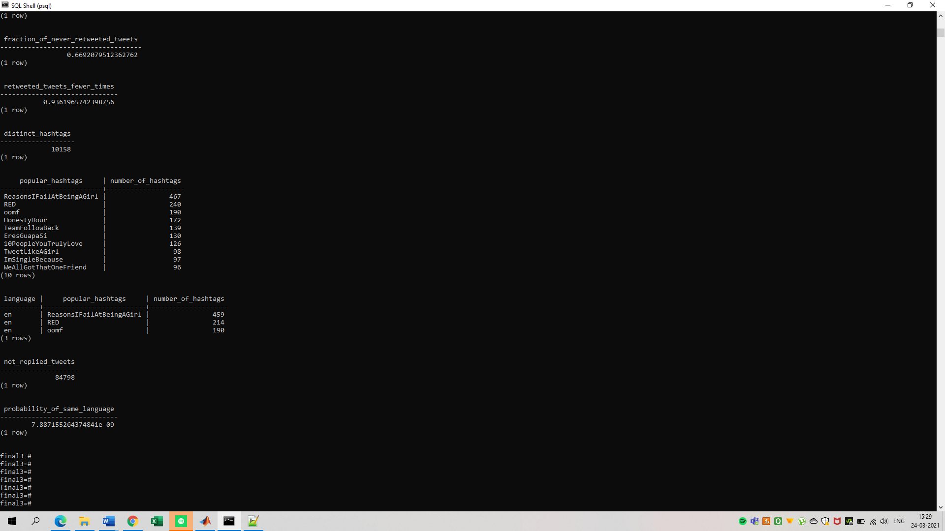

Query 4.1

o/p - > Tweets which are not Replied

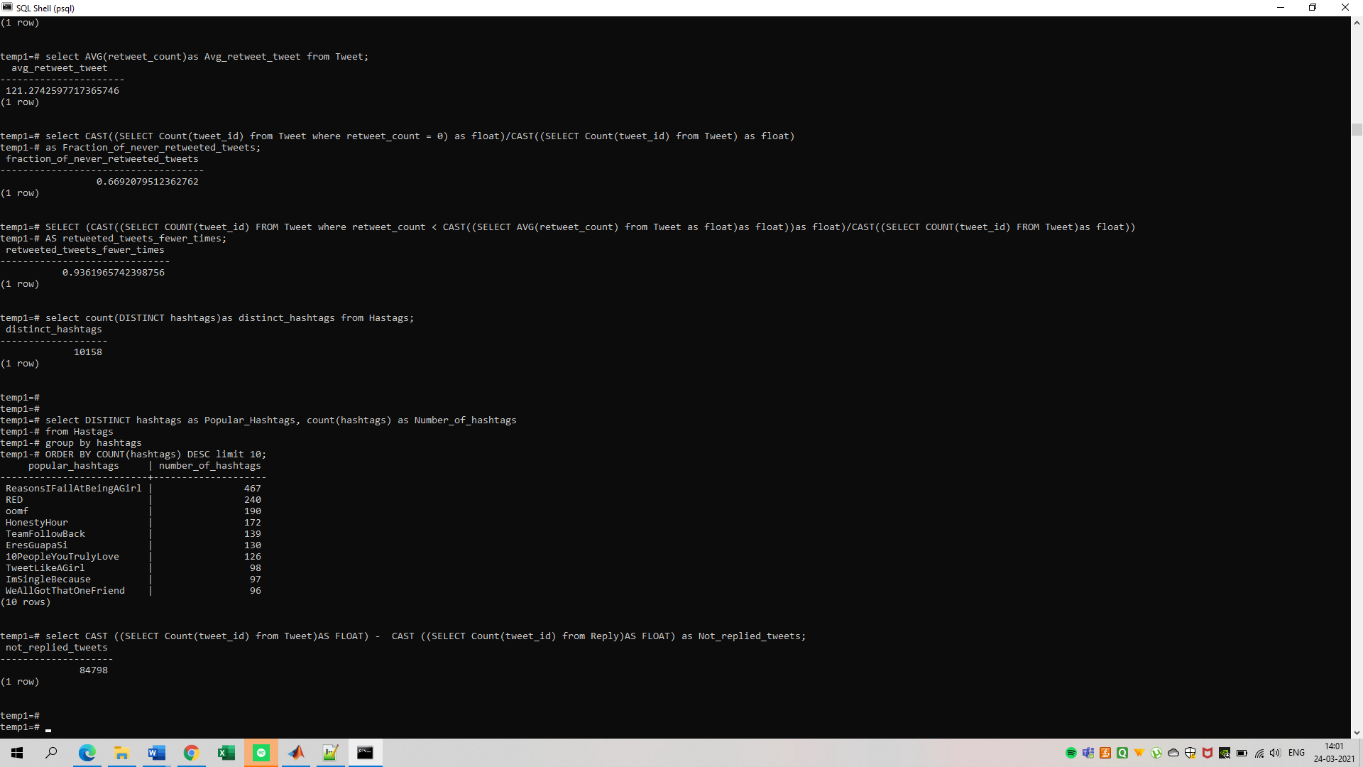

Query 4.2

o/p - >Probability of same language

